Drifting Wave Buoy using ORBCOMM Data Transmission

Tetsuya Uwai
Japan Meteorological Agency
buoyunit@hq.kishou.go.jp

As was introduced at the Scientific and Technical Workshop of the 16th DBCP held in Victoria, BC, Canada on 16 – 17th October 2000, the Japan Meteorological Agency (JMA) commenced the operation of drifting wave buoys which utilize ORBCOMM as telecommunication means in June 2000. This is a brief follow-up report including some examples of observations and the performance of telecommunication throughout the operation for 16 months up to September 2001.

Overview
JMA commenced the operational deployment of drifting wave buoys around Japan in June 2000 to monitor severe weather conditions (waves and air pressure) for prevention of meteorological disasters as well as sea surface temperature. 18 buoys have been deployed from JMA research vessels by the end of September 2001. 12 buoys are scheduled to be deployed a year. The technical aspects of the buoy are as follows:
Configuration of the buoy:
64cmφ×66cm (height), 60kg (weight), aluminum alloy hull.
Observing elements:
Air pressure, sea surface temperature and significant wave height/period.
Telecommunication:
Two-way via ORBCOMM bent-pipe mode, every three hours (or hourly if necessary).
99% of the observations are received by JMA within fifteen minutes.
Power source:
Li/MnO2 battery (3V, 10Ah), 76 cells.
GTS distribution:
BUOY message (FM-18) with header SSVB01(-19) RJTD.
Lifetime:
Six months.
Some of landed buoys were recovered and re-deployed.
Cost:
Buoy manufacture : About US$25,000 for each buoy.
Telecommunication : US$80 – 120/month/buoy in normal use.
Specifications
Air pressure:
air intake : barometer port on the top plane with micro-filter (GORE-TEX) preventing water entering.
sensor : silicon capacitive absolute pressure sensor.
sampling : 2 Hz, 30 sec.
averaging : medial 40 values in the 60 samples.
range of measurement : 920 – 1040 hPa.
output unit : 0.1 hPa.
Sea surface temperature:
sensor : platinum resistance thermometer
sampling : 2 Hz, 30 sec.
averaging : medial 40 values in the 60 samples.
range of measurement : -5 - +45 degree Celsius.
output unit : 0.1 degree.
Significant wave height and period:
sensor : one-axis accelerometer supported by gimbals to keep vertical. Observed acceleration data are integrated twice to change into vertical displacement.
sampling : 2 Hz, 512 sec.
processing : individual waves are extracted applying “zero-up-cross” method to the 1,024 samples. Then significant wave height and period are calculated as the averages of upper third of the individual waves.
range of measurement : 0 - 25 m for height and 4 - 20 sec. for period.
output unit : 0.1 m for height and 0.1 sec. for period.
Positioning and time keeping:
method : GPS
positioning unit : 0.001 degree for longitude and latitude.
time keeping : time data are used for CPU timer correction.
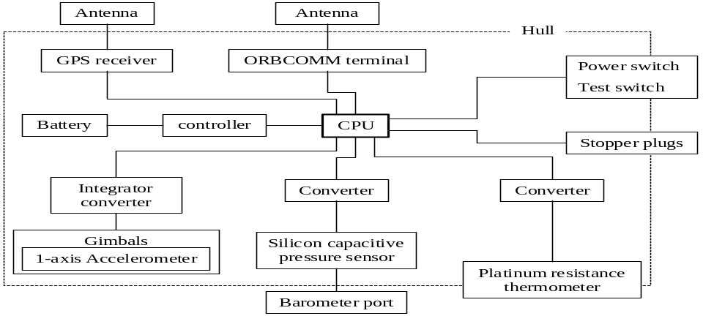

Figure:

Buoy construction chart

Field operations around Japan
From a viewpoint of disaster prevention, JMA is particularly interested in the high waves caused by typhoons, developing lows, or winter monsoon bursts.
It is difficult to keep appropriate position of the buoys for typhoon observation in south of Japan due to the Kuroshio Current which flows eastward at the speed of 1 – 2 m/s. Further research is required for deployment position or timing for effective and efficient operation of buoys.
Because the north westerly monsoon prevails over the Sea of Japan in winter, the buoys tends to land up on Japanese coast. Newly designed drogues were attached to some buoys deployed in the area in order to reduce the wind effect. The drogue is a holey-sock type with a diameter of 94cm, and a length of 172cm, and it is hung with a rope in the depth of 9m from a surface float with a diameter of 30cm. The float and the buoy are connected with a rope through a pipe with a length of 1m. In an example when deployed the buoys with/without drogue simultaneously (deploy No.01-02 and No.01-03 in the table below) , no obvious difference were seen in the observed values for atmospheric pressure and wave height/period with the buoys, but movement of the buoy with drogue was clearly slower than that of without drogue.
When some buoys landed on the seashore, some of them were deployed again.
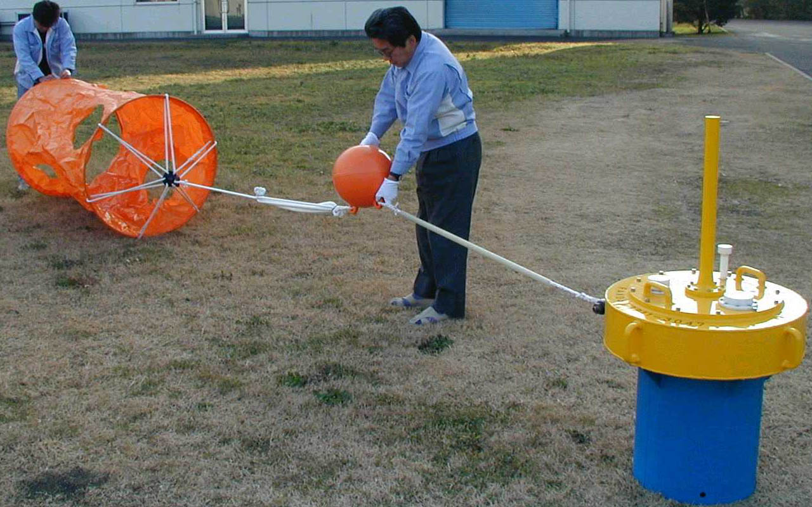

Photo:
Connecting a drogue to a buoy

Table:
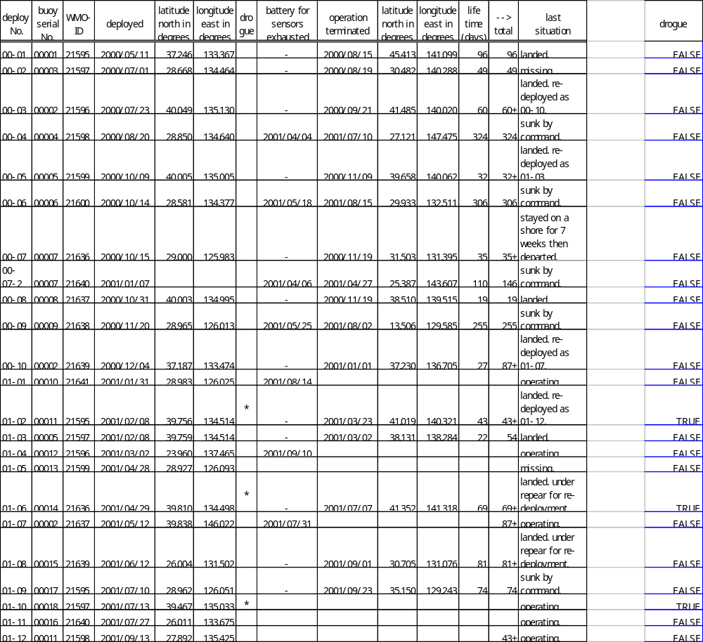
Summary of the operation of the first 18 buoys

Examples of observation
The paths of the buoys and the time series of observation data in July 2001 are shown below. The low pressure and the high waves which are observed around July 3rd were caused by typhoon Utor and those around July 27th were by Kong-rey and Toraji. The buoy 21596 observed the minimum pressure 970.2 hPa and the buoy 21637 observed the maximum wave height 11.2 m.

Figure: Time series of JMA drifting buoy observation. The upper panel shows paths of the buoys. Circles denote the position at 00hUTC everyday. The lower panel shows time series of observation data.
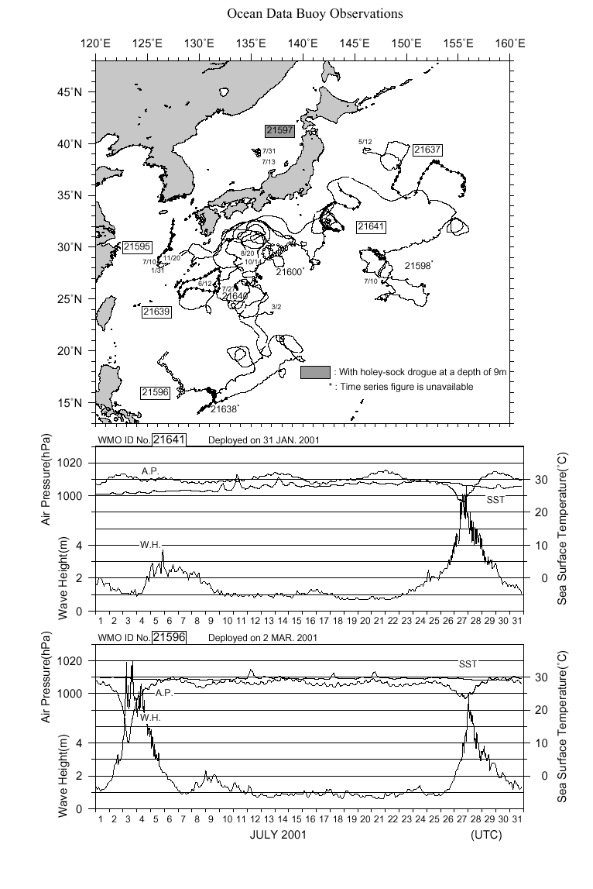

Figure: continue
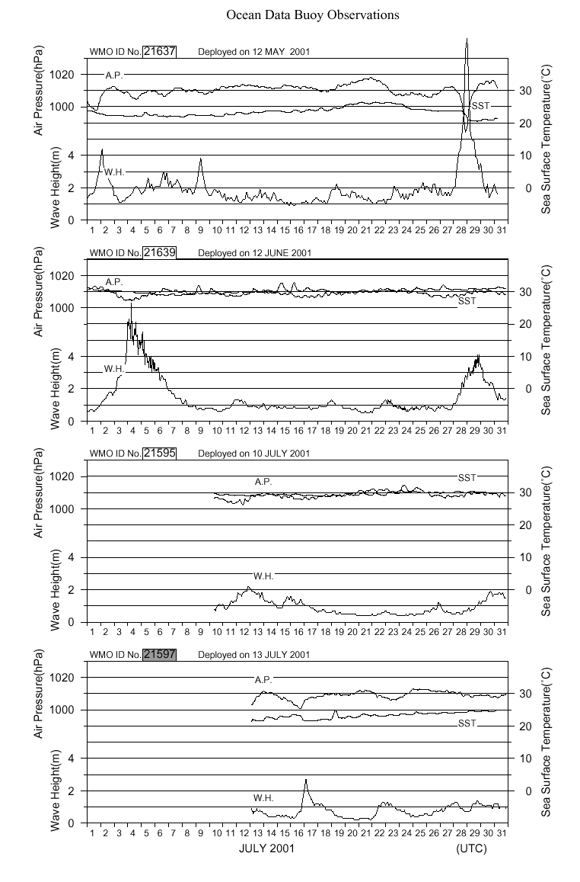

Telecommunication - Timeliness and reliability –
Statistics on the telecommunication for the period from June 2000 to February 2001 is shown below. Almost all the data (98.8%) were received within 15 minutes after they had observed. Only a few data were received with about 3 hours delay, probably because there were no satellites over the buoy at the time. Most of the delays over four hours were due to troubles in the mail server or LAN in JMA office.
It is concluded that the telecommunication system which is adopted to the drifting buoys is fully reliable for our operational use.
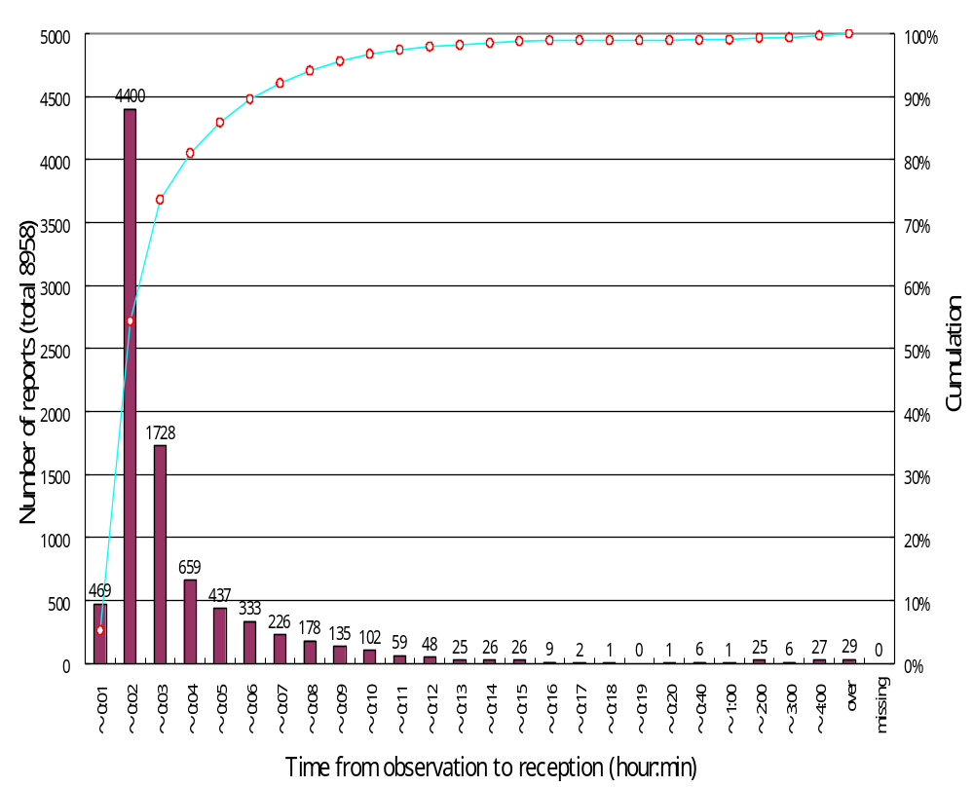

Figure:
The bar graph shows the number of reception for every section, and the open circle denotes the cumulation.

